Introduction:
This report presents an analysis of a sales dataset to identify key sales trends, product performance, profitability, and business insights. The data was cleaned and analyzed using Excel, SQL, and PowerBi to support accurate findings and recommendations.
Dataset Overview:
It has a total of 100 sales records which are distributed in to 10 columns: OrderID, Customer name, date, product, city, quantity, unit price, category, salesperson and gender. There are six products involved Laptop, Printer, Mouse, Desk, Table, and Notebook. These are categorized into three (Electronic, Furniture and Stationery), With sales operations in five cities(Kumasi, Lagos, Lomé, Accra and Abuja), handled by 5 salespersons.
The dataset contains several data quality issues. There are 14 missing values under gender column; 9 missing in quantity; one missing in ‘unit price’ and one in ‘City’. There is one Duplicate row. The text format in the Customer Name and gender column are inconsistent. There are also, inconsistent text space and capitalization under City column. The date also has one inconsistent date format. These were all cleaned to allow for quality data analysis.
Data set cleaning:
The dataset was cleaned using Power Query in Excel before analysis. First, duplicate records were identified, and removed to ensure that each transaction do not appear twice. Missing values in the Gender, Quantity, Unit Price, and City columns were identified and handled appropriately. Missing Gender and City values were replaced with “Unknown,” this is more appropriate because the column contains text, while missing Quantity and Unit Price values were replaced with ‘0’ being numeric columns.
The Order Date column was reviewed and incorrect date format were corrected. Customer names and city names were standardized by removing unnecessary spaces and correcting inconsistent text formatting. Gender values were also standardized to ensure consistency.
After completing the cleaning process, the dataset was reviewed to ensure that the values were consistent and suitable for analysis.
Key Findings:
- Electronics form the strongest sales category:
  - Electronics 181,250
  - Furniture 18,115
  - Stationery. 340
- Laptop is the dominant product
  - Laptop generated 157,200 in sales. That represents 79% of the sales generated.
  - It is far ahead of printer 22,250 and Desk 14,220
  - This shows the business over reliance on one product. If the demand for laptop drops the business could significantly nosedive.
- There is significant monthly sales fluctuations with April recording the highest sales:
  - April - 46, 915
  - July. - 42,105
  - May. - 19,155
  - Sept - 175 (extremely low)
  - Oct. - 565
- Accra generated the highest sales:
  - Accra. - 58,795
  - Kumasi – 47,855
  - Abuja - 38, 055
  - Lomé. – 29,835
  - Lagos. – 25,130
  - It is expected that a city like Lagos should naturally compete with Accra for the highest sales rather it came last. This pointed out that sales have other determinants other than merely the city.
- Emeka recorded the highest salesperson sales:
  - Emeka. – 76,835
  - Diana. – 65,420
  - Alice. - 22,340
  - Charles – 9075
  - The sales record showed higher concentration on Laptop by the top 3 salespersons. It could be that they receive more incentives from the company on sales of laptops. It could as well mean that they found it easier to market and sell laptops.
Dashboard Visuals
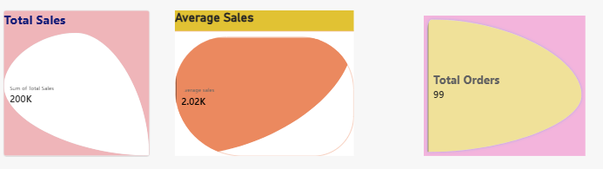

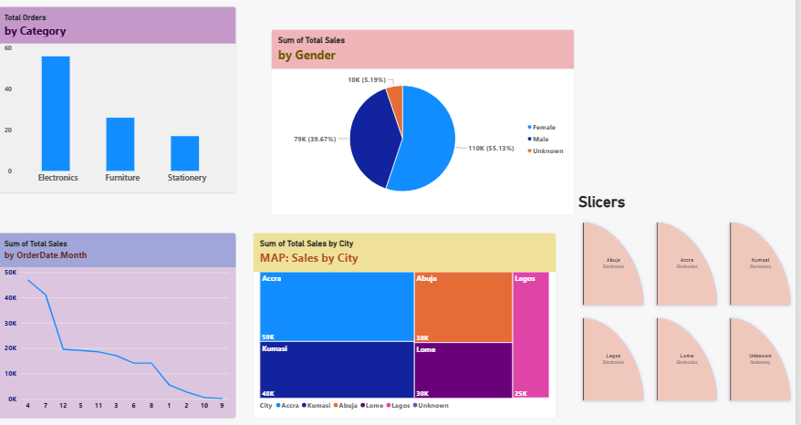
Recommendations:
  - Laptop stock and market should be maintained
  - Laptop should be used to boost the sales of other products such as mouse and printer by trying bundling them together
  - Promotions and discounts should be tried
  - Incentives could be given to encourage the salespersons to market other products with more vigour
  - The cause of high volatility in monthly sales should be investigated to know how to strategize to arrest the trend
  - There is a great need to diversify to better profitable products to avoid too much reliant on Laptop and to avoid the risk involved.
Conclusion:
The analysis shows that the business has a strong sales position in the Electronics category, driven predominantly by Laptop sales. Accra is the strongest-performing market, while significant differences exist among cities and salespersons. The substantial fluctuations in monthly sales also require further investigation.
Although the strong performance of laptops represents an important business opportunity, the high concentration of revenue around one product creates a potential risk. A combination of product diversification, cross-selling, targeted promotions, salesperson incentives, and further investigation of sales fluctuations could help the business achieve more balanced and sustainable growth and profit.

